**LAB NO:4**

**TASK:**

Develop the RMI Callback application of Payroll and Payroll Message services for calculating the earnings.

**PROGRAM:**

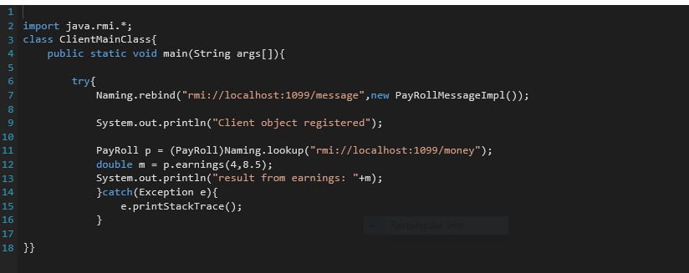

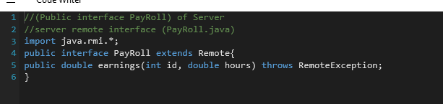

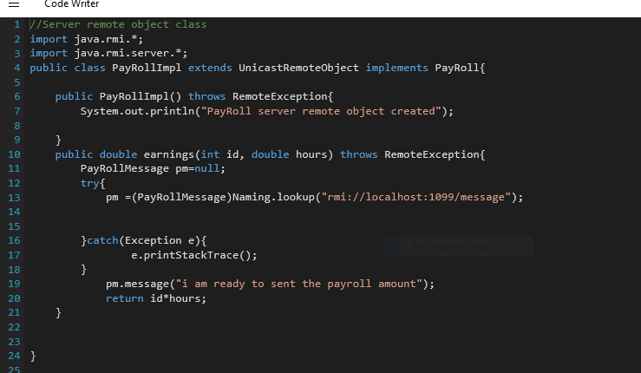

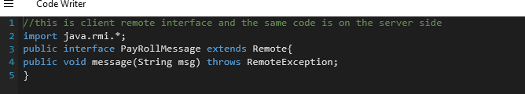

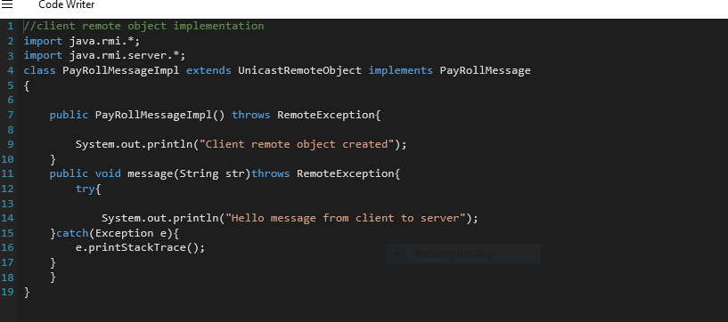

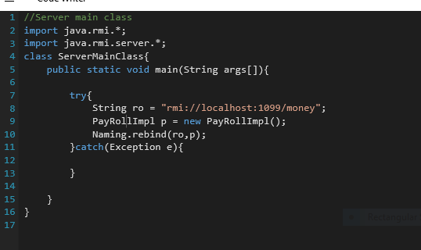

**OUTPUT:**

